**PRACTICAL NO: 01**

**AIM:** Understanding the sensor node hardware (for example sensor, node, base station, GUI)

**1. Weather Forecast Sensor**

A] Davis Instruments

**Product Name**: Vantage Pro2 Weather Station

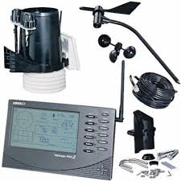

**Node**: Integrated Sensor Suite (ISS) Includes temperature, humidity, rain, and wind sensors.

Transmits data wirelessly to the console.

**Uses**: Agricultural weather monitoring. Personal or professional weather forecasting. Research and education.

B] Bosch Sensortec

**Product Name:** BME280 Environmental Sensor

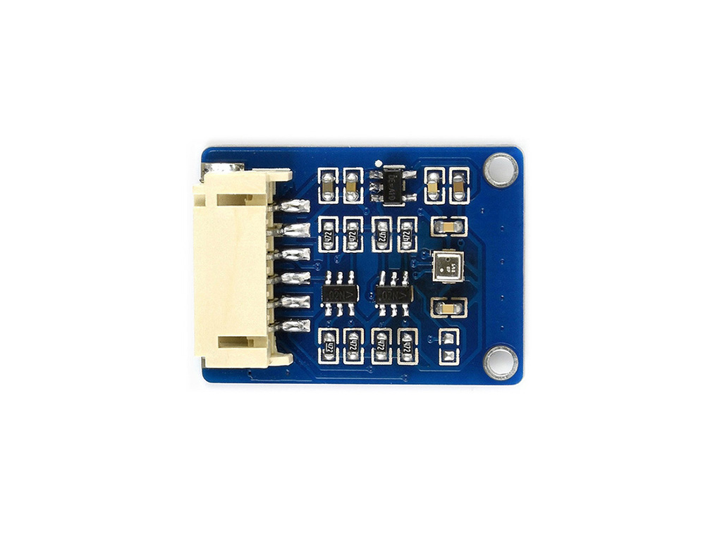

**Node:** Weather Sensor Node Measures temperature, humidity, and atmospheric pressure.

Can be integrated into IoT systems and connected via Wi-Fi or Bluetooth.

**Uses:** Indoor and outdoor climate monitoring.Smart home systems and HVAC control.Weather station integration for IoT applications.

**2.Temperaature Sensor**

A] Texas Instruments

**Product Name:** TMP117 High-Accuracy Digital Temperature Sensor

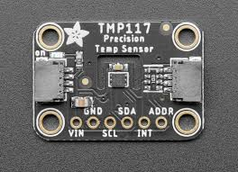

**Node:** IoT Temperature Sensor Node Features a precision digital output for direct microcontroller interface. Connects via I2C or SMBus interface.

**Uses:**

Industrial temperature monitoring.Medical devices (e.g., thermometers).Smart home applications (e.g., thermostats).

B] Honeywell

**Product Name:** TTS Series Temperature Sensors

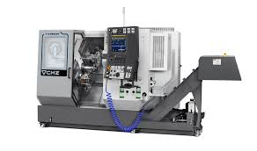

**Node:** Thermal Sensor Node. Compact design with fast response time. Supports analog output for easy integration.

**Uses:**

HVAC systems for efficient climate control. Food and beverage storage monitoring. Industrial process automation.

**3. Metal Detector Sensor**

A] Minelab

**Product Name:** GPZ 7000 Metal Detector

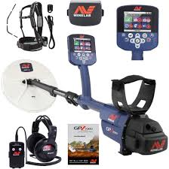

**Node:** ZVT Technology Node Uses Zero Voltage Transmission (ZVT) for deep gold detection. Highly sensitive to small and large gold nuggets.

**Uses:** Gold prospecting and treasure hunting. Archaeological and geological exploration. Industrial applications for metal recovery.

B] Garrett Electronics

**Product Name:** Garrett Super Scanner V

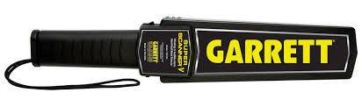

**Node:** Handheld Metal Detection NodePortable and powered by a rechargeable battery.Detects metallic objects with audio and visual alerts.

**Uses:** Security screening (airports, events, etc.). Industrial metal detection in manufacturing.Detecting buried utilities or pipes.

**4. Humidity Sensor**

A] Sensirion

**Product Name:** SHT31 Humidity and Temperature Sensor

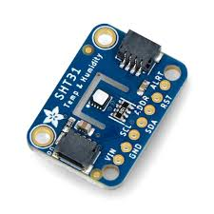

**Node:** Environmental Sensor Node Measures both relative humidity and temperature with high accuracy. Connects via I2C or voltage output for integration with microcontrollers.

**Uses:** HVAC systems for climate control. Weather monitoring stations. Industrial and agricultural applications (e.g., greenhouses).

B] Honeywell

**Product Name**: HIH-4000 Series Humidity Sensors

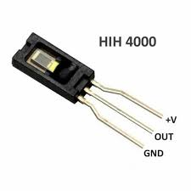

**Node:** Analog Humidity Sensor Node Provides a linear voltage output proportional to relative humidity.Requires low power and is ideal for battery-operated systems.

**Uses:** Medical devices (e.g., ventilators). Indoor air quality monitoring. Industrial drying processes and storage systems.

**5. Ultrasonic Sensor**

A] MaxBotix

**Product Name:** MB1010 LV-MaxSonar-EZ1 Ultrasonic Sensor

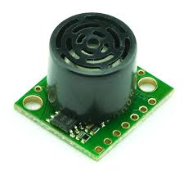

**Node:** Ultrasonic Distance Measuring Node Detects objects within a range of 6 meters. Outputs data via analog, PWM, and serial interfaces.

**Uses:** Robotics for obstacle detection and navigation. Tank level measurement. Parking assistance systems.

B] Pepperl+Fuchs

**Product Name:** UC4000-30GM-IUR2-V15 Ultrasonic Sensor

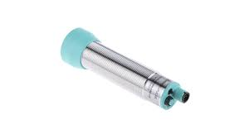

**Node:** Industrial Ultrasonic Sensing Node Offers a detection range of up to 4 meters. Provides adjustable sensitivity and IO-Link compatibility.

**Uses:** Industrial automation for object detection. Material handling and conveyor systems. Liquid level monitoring in tanks and reservoirs.